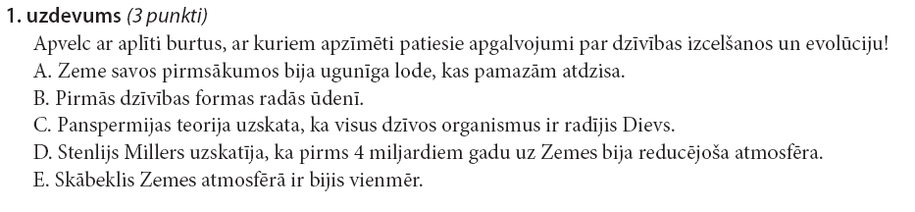

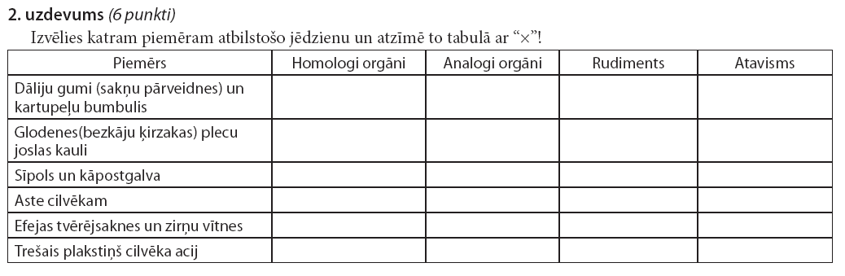

3. uzdevums (12 punkti)
Izskaidro jēdzienus:
Atavisms ______________________________________________________________________
Rudiments _____________________________________________________________________
Homologi orgāni ________________________________________________________________
Analogi orgāni __________________________________________________________________
Diverģence _____________________________________________________________________
Konverģence ___________________________________________________________________
Mainība _______________________________________________________________________
Dabiskā izlase __________________________________________________________________
Mākslīgā izlase _________________________________________________________________
Filoģenētiskā rinda _______________________________________________________________
Evolūcijas pierādījumi ____________________________________________________________ ____________________________________________________________________________________________________________________________________________________________________________________________________________________________________________________________________________________________________________________________________________________
