Pārbaudes darbs kulturoloģijā „Zīmes un simboli”
____________________________________
1.uzdevums. Skaidrojiet jedzienus! Miniet piemērus! 3p.
Zīme -_________________________________________________________________________________
______________________________________________________________________________________________________________________________________________________________________________

Simbols - ______________________________________________________________________________
______________________________________________________________________________________________________________________________________________________________________________
Monoteisms- ___________________________________________________________________________
______________________________________________________________________________________________________________________________________________________________________________

2.uzdevums. Sašķirojiet zīmes pēc to veidiem! 12
1. 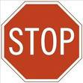 | 2. 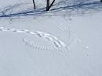 | 3. 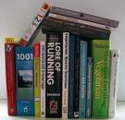
4. 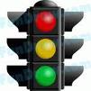 | 5.  | 6. 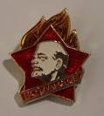

Zīmju veidi.
A. Dabiskās zīmes | B.Konvencionālās zīmes | C. Ikoniskās zīmes | D. Funkcionālās zīmes

Pamatojiet savu izvēli!
1. | 2. | 3.
4. | 5. | 6.

3.uzdevums. Kādi ir Latvijas valsts simboli?Ko tie simbolizē? 5p.
____________________________________________________________________________________________________________________________________________________________________________________________________________________________________________________________________________________________________________________________________________________________________________________________________________________________________________________________________________________________________________________________________________________________________________________________________________________________________________________________________________________________________________________________________________________________________________________________________________________________________________________________________________________________________________________________________________________________________________________________________________________________________________________________________________________

3.uzdevums. Kurām reliģijām un kultūrām atbilst šie simboli? Mini simbolu jēgu!8.p
1. 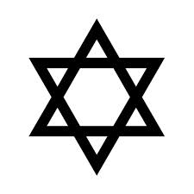2. 3.4.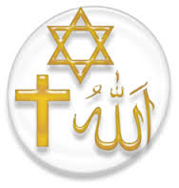5. 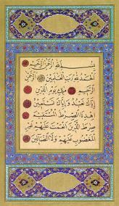 6.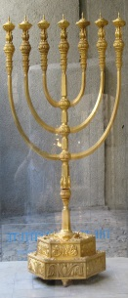 7.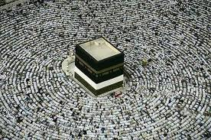 8.
____________________________________________________________________________________________________________________________________________________________________________________________________________________________________________________________________________________________________________________________________________________________________________________________________________________________________________________________________________________________________________________________________________________________________________________________________________________________________________________________________________________________________________________________________________________________________________________________________________________________________________________________________________________________________________________________________________________________________________________________
___________________________________________________________________________________________________________________________________________________________________________________________________________________________________________________________________________________________________________________________________________________________-
___________________________________________________________________________________________________________________________________________________________________________________________________________________________________________________________________________________________________________________________________________________________-
1 | 2 | 3 | 4 | 5 | 6 | 7 | 8 | 9 | 10
0-2 | 3-5 | 6-9 | 10-12 | 13-15 | 16-18 | 19-21 | 22-24 | 25-27 | 28

