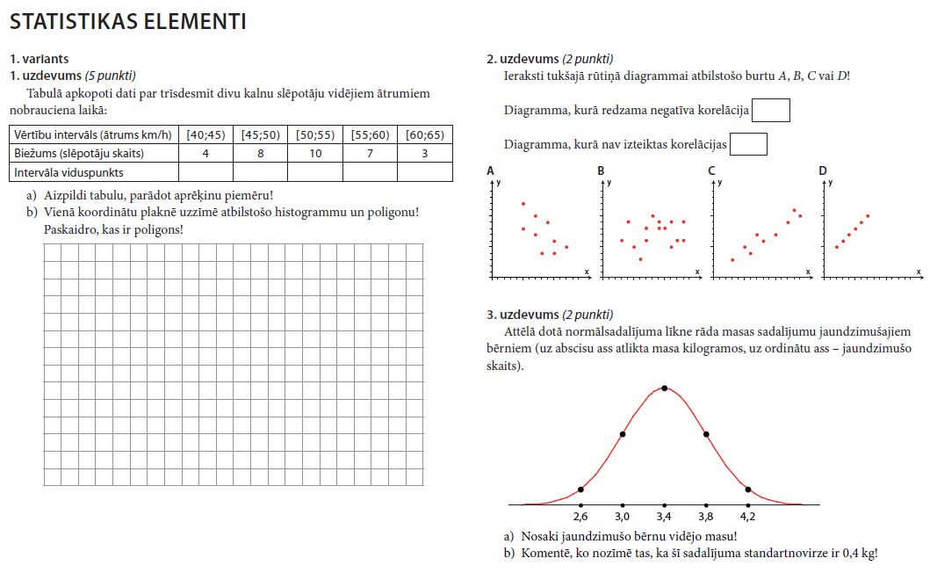
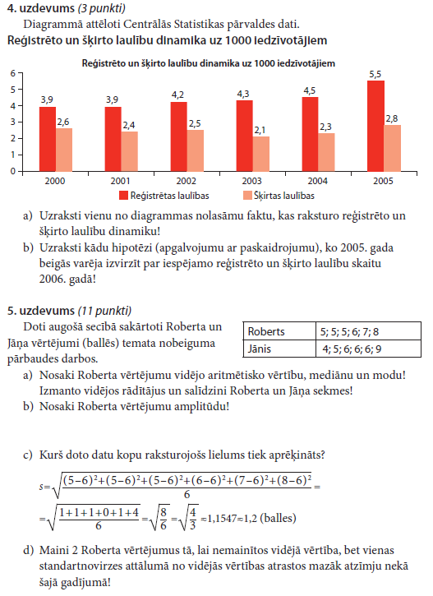
Vērtēšanas tabula:
Balles | 1 | 2 | 3 | 4 | 5 | 6 | 7 | 8 | 9 | 10
Procenti | 1-9% | 10-19% | 20-32% | 33-44% | 45-56% | 57-66% | 67-76% | 77-85% | 86-94% | 95-100%

