Pārbaudes darbs kulturoloģijā
„Daba. Civilizācija”
_____________________________

1.uzdevums. Skaidro jēdzienus!4p.
Fetišs - _______________________________________________________________________
_____________________________________________________________________________
Amulets - _____________________________________________________________________
_____________________________________________________________________________
Tabu - ________________________________________________________________________
_____________________________________________________________________________
Poligāmija - ___________________________________________________________________
_____________________________________________________________________________

2.uzdevums. Atbildi uz jautājumiem! Atbildes pamato! 4 p.
1 Kādi dabas faktori noteica seno ēgīptiešu pasaules uzskatu?
____________________________________________________________________________________________________________________________________________________________________________________________________________________________________________________________________________________________________________________
__________________________________________________________________________________________________________________________________________________________

2. Raksturojiet likumdošanas aizsākumus Divupē!
____________________________________________________________________________________________________________________________________________________________________________________________________________________________________________________________________________________________________________________
__________________________________________________________________________________________________________________________________________________________

3.uzdevums. Kuru kultūru arhitektūrai ir raksturīgas šādas būves? Nosauciet šīs celtnes un raksturojiet to nozīmi! 4 p.
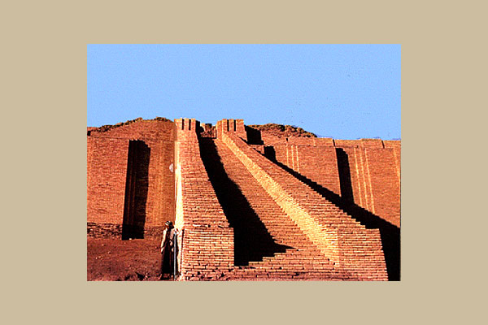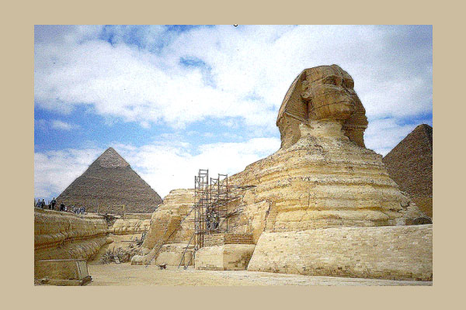

______________________________________________________________________________________________________________________________________________________________________________________________________________________________________________________________________________________________________________________________________________________________________________

4. uzdevums. Aizpildiet tabulu! Salīdziniet divas kultūras! 8p.

 | Ēģipte | Mezopotāmija
Priekšstati par pēcnāves dzīvi

Māksla

5. uzdevums. Noliedz vai pamato šo apgalvojumu! 8p.
„Novelciet cilvēkam ādu un jūs tur atradīsiet mežonīgu pērtiķi.”
(Roberts Hovards, amerikāņu fantasts)
______________________________________________________________________________________________________________________________________________________________________________________________________________________________________________________________________________________________________________________________________________________________________________
______________________________________________________________________________________________________________________________________________________________________________________________________________________________________________________________________________________________________________________________________________________________________________

Balles | 1 | 2 | 3 | 4 | 5 | 6 | 7 | 8 | 9 | 10
Punkti | 0-2 | 3-5 | 6-9 | 10-12 | 13-15 | 16-18 | 19-21 | 22-24 | 25-26 | 27-28

