4. ieskaite
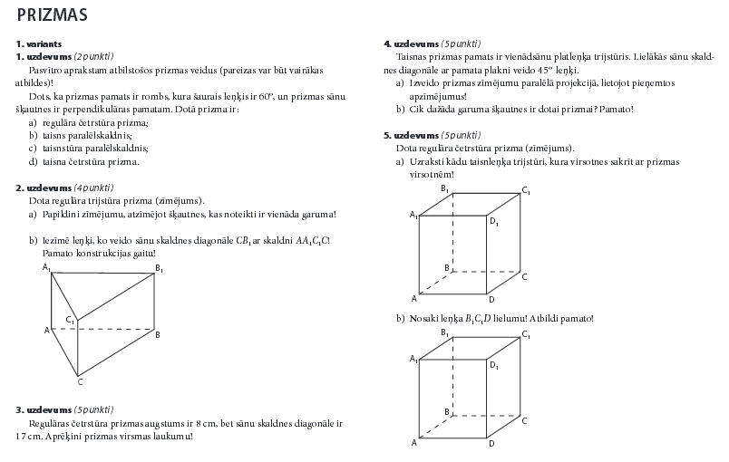
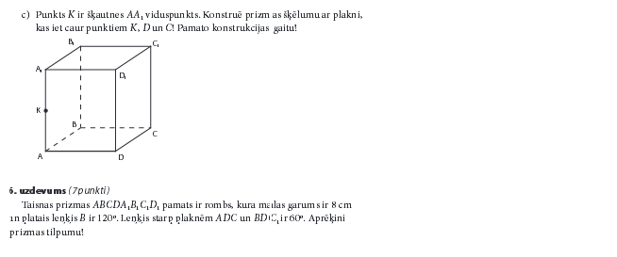
Vērtēšanas tabula:

Balles | 1 | 2 | 3 | 4 | 5 | 6 | 7 | 8 | 9 | 10
Procenti | 1-9% | 10-19% | 20-32% | 33-44% | 45-58% | 59-70% | 71-82% | 83-92% | 93-97% | 98-100%

